Roshan Kosaraju
Mechatronics Engineering Technology (MXET) — Texas A&M University — TAMU
Project R1D2
Variable-Configuration Spherical Rolling Robot with Magnetic Mass Actuation
(“R1D2” — Robot 1, Design 2 — working project designation; no formal name assigned yet)

1. Overview & Motivation
This project explores a locomotion mechanism for a spherical mobile robot: an internally mounted eccentric mass, held at a fixed radius from the sphere's center and actuated angularly by a ring of commutated electromagnets. Rather than driving the sphere with an external wheel or a motor-swung pendulum, the mass is magnetically “held” off-center and advanced from magnet to magnet as the sphere rolls — continuously maintaining a gravity-torque offset that drives rolling motion without any moving mechanical linkage crossing the shell boundary.
The actuation concept is adapted from a class project on electromagnetic tuned mass dampers (TMDs) for skyscraper sway mitigation. Where a TMD dissipates and redirects a structure's oscillatory energy through a controlled internal mass, this design inverts that principle: instead of damping motion, the internal mass is driven to actively generate it, using a similar electromagnetic actuation logic.

2. Concept & Mechanism
The robot consists of a spherical outer shell housing a single eccentric mass on a rigid arm, pivoting about the sphere's geometric center at a fixed radius r. A ring of electromagnetic coils is embedded circumferentially inside the shell. By energizing coils in sequence (commutation), the mass's angular position relative to the ground-fixed vertical can be advanced or held, independent of the shell's own rotation — similar in principle to phase-switching in a stepper or reluctance motor, applied here to sustain an eccentric-mass rolling torque rather than continuous rotation.
- No internal motor or gear linkage crossing the shell wall — actuation is fully magnetic, improving sealing and reducing mechanical failure points.
- Mass held at fixed radius (single controlled DOF: angular position θ), simplifying the actuation problem relative to a variable-radius design considered earlier in development.
- Commutation angle can, in principle, be tuned to control rolling speed and direction (reversing the commutation sequence).
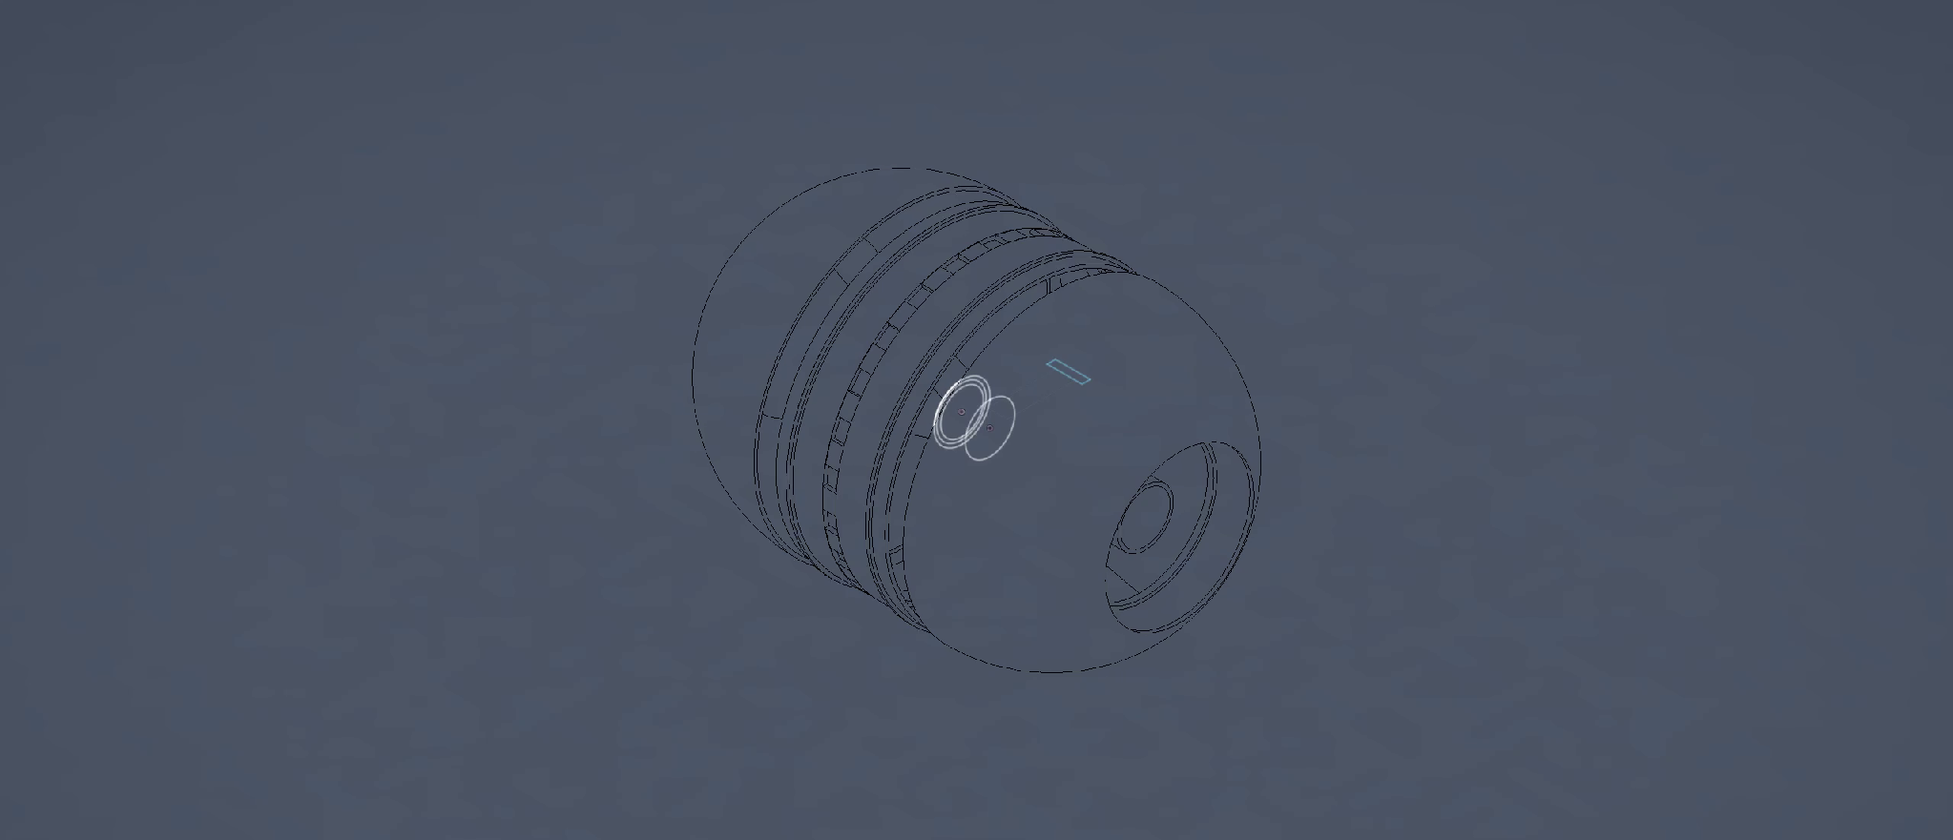
Figure 1 — CAD render of the R1D2 outer shell, showing the electromagnet ring (ribbed band) and internal cavity for the eccentric mass assembly.

3. Preliminary Dynamics
Modeling the system as a rolling sphere (mass M, radius R, moment of inertia Iₛ) coupled to an internal eccentric mass (m, fixed radius r, angular position θ) gives a two-degree-of-freedom system in generalized coordinates φ (sphere roll angle) and θ (mass angular position). Preliminary Lagrangian analysis shows the coupling between shell rotation and mass motion enters only through terms involving θ̇ and θ̈ — meaning a statically held offset mass produces no net roll, and continuous angular advancement of the held mass (i.e., the commutation scheme) is dynamically necessary to sustain rolling motion, not simply a convenient implementation choice. This is a useful early result to alter the actuation logic.
The equations of motion are still being refined — the pages below are my working derivation (Lagrangian formulation, generalized coordinates φ and θ). I'm continuing to verify the coupling terms and plan to validate the model numerically (Simulink/Simscape) before moving to hardware sizing of the electromagnet ring.
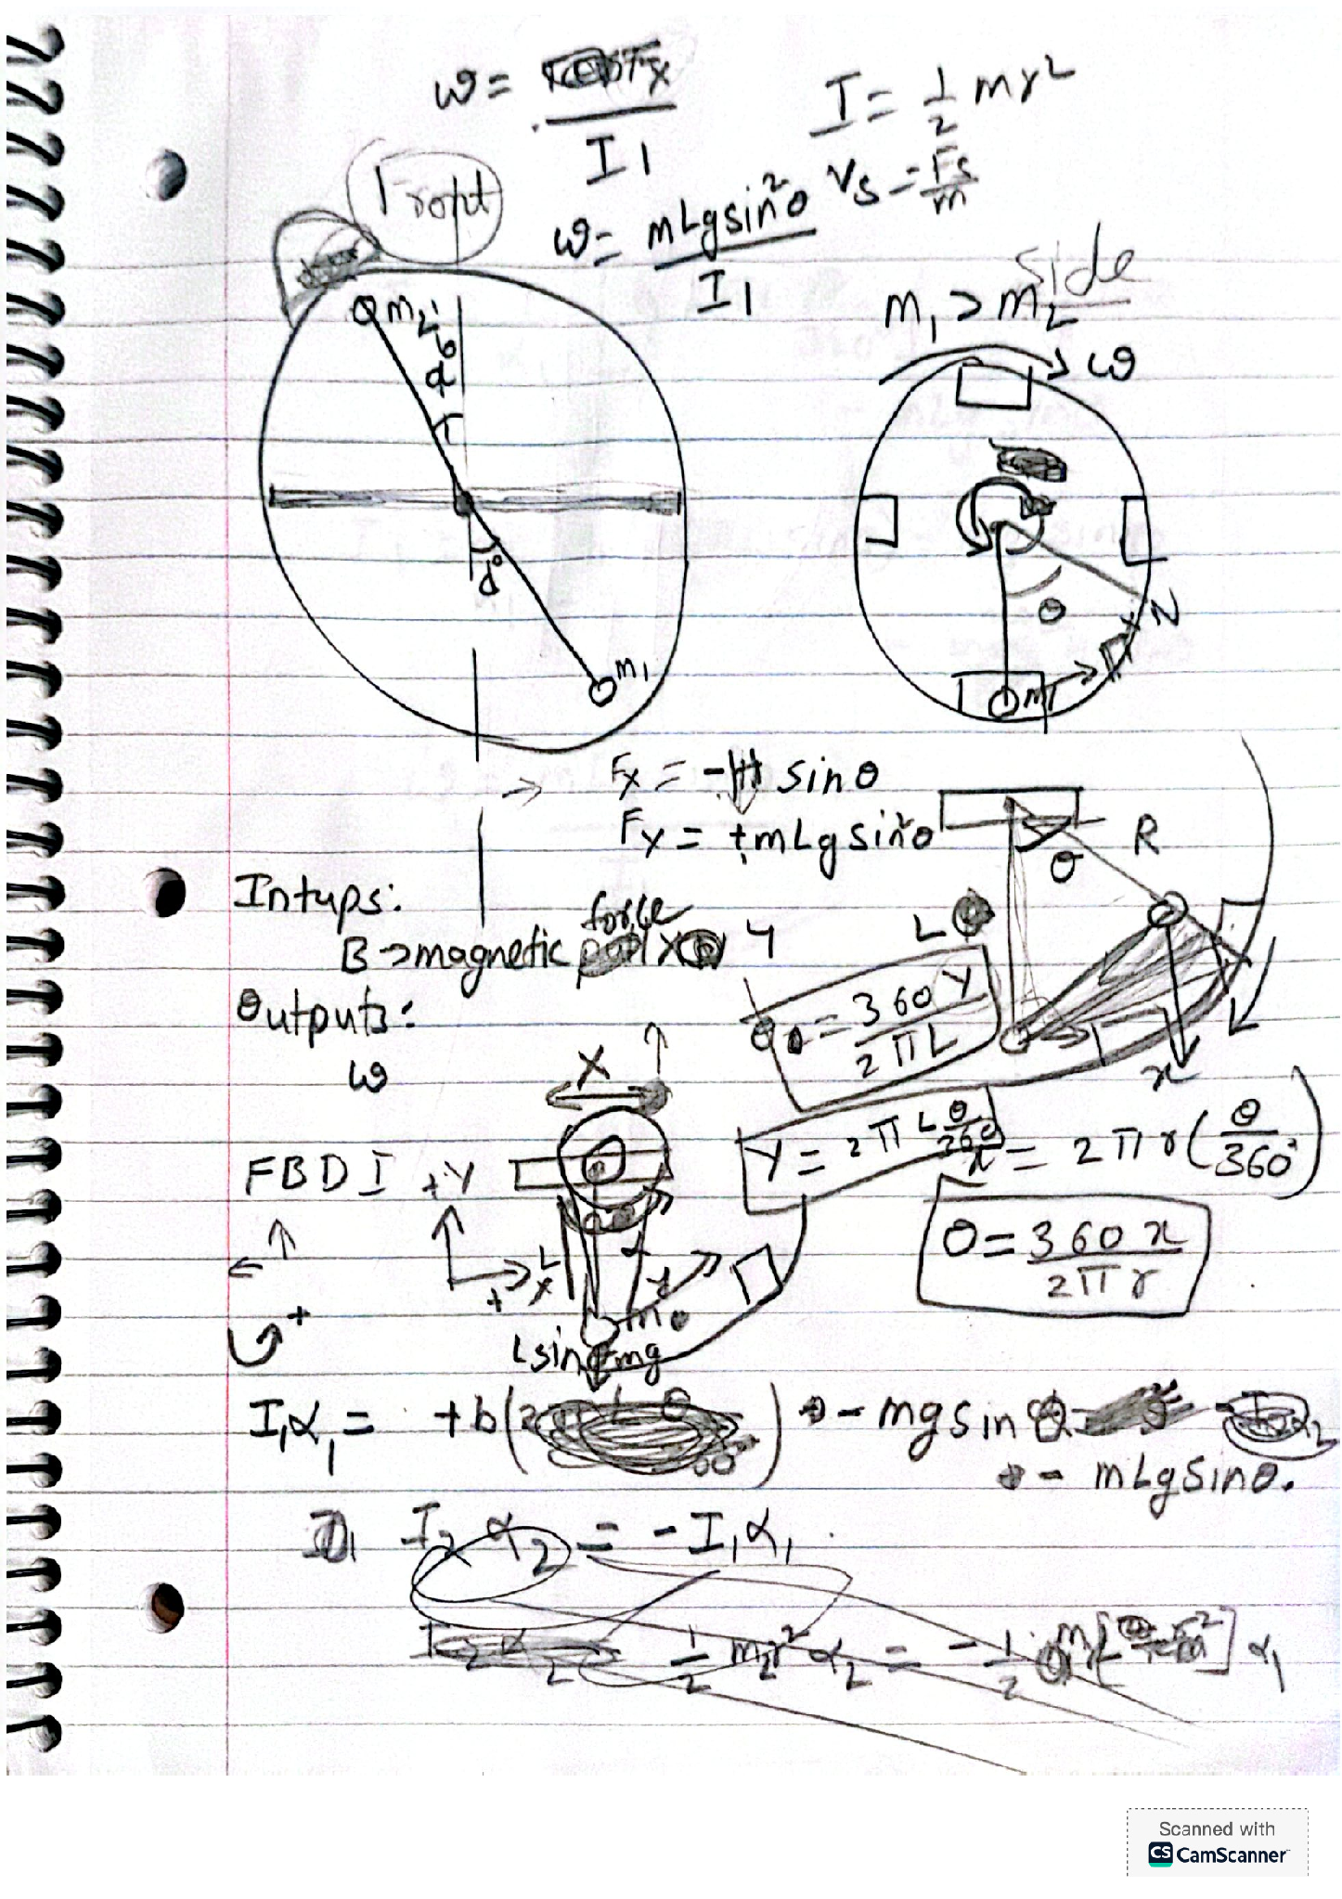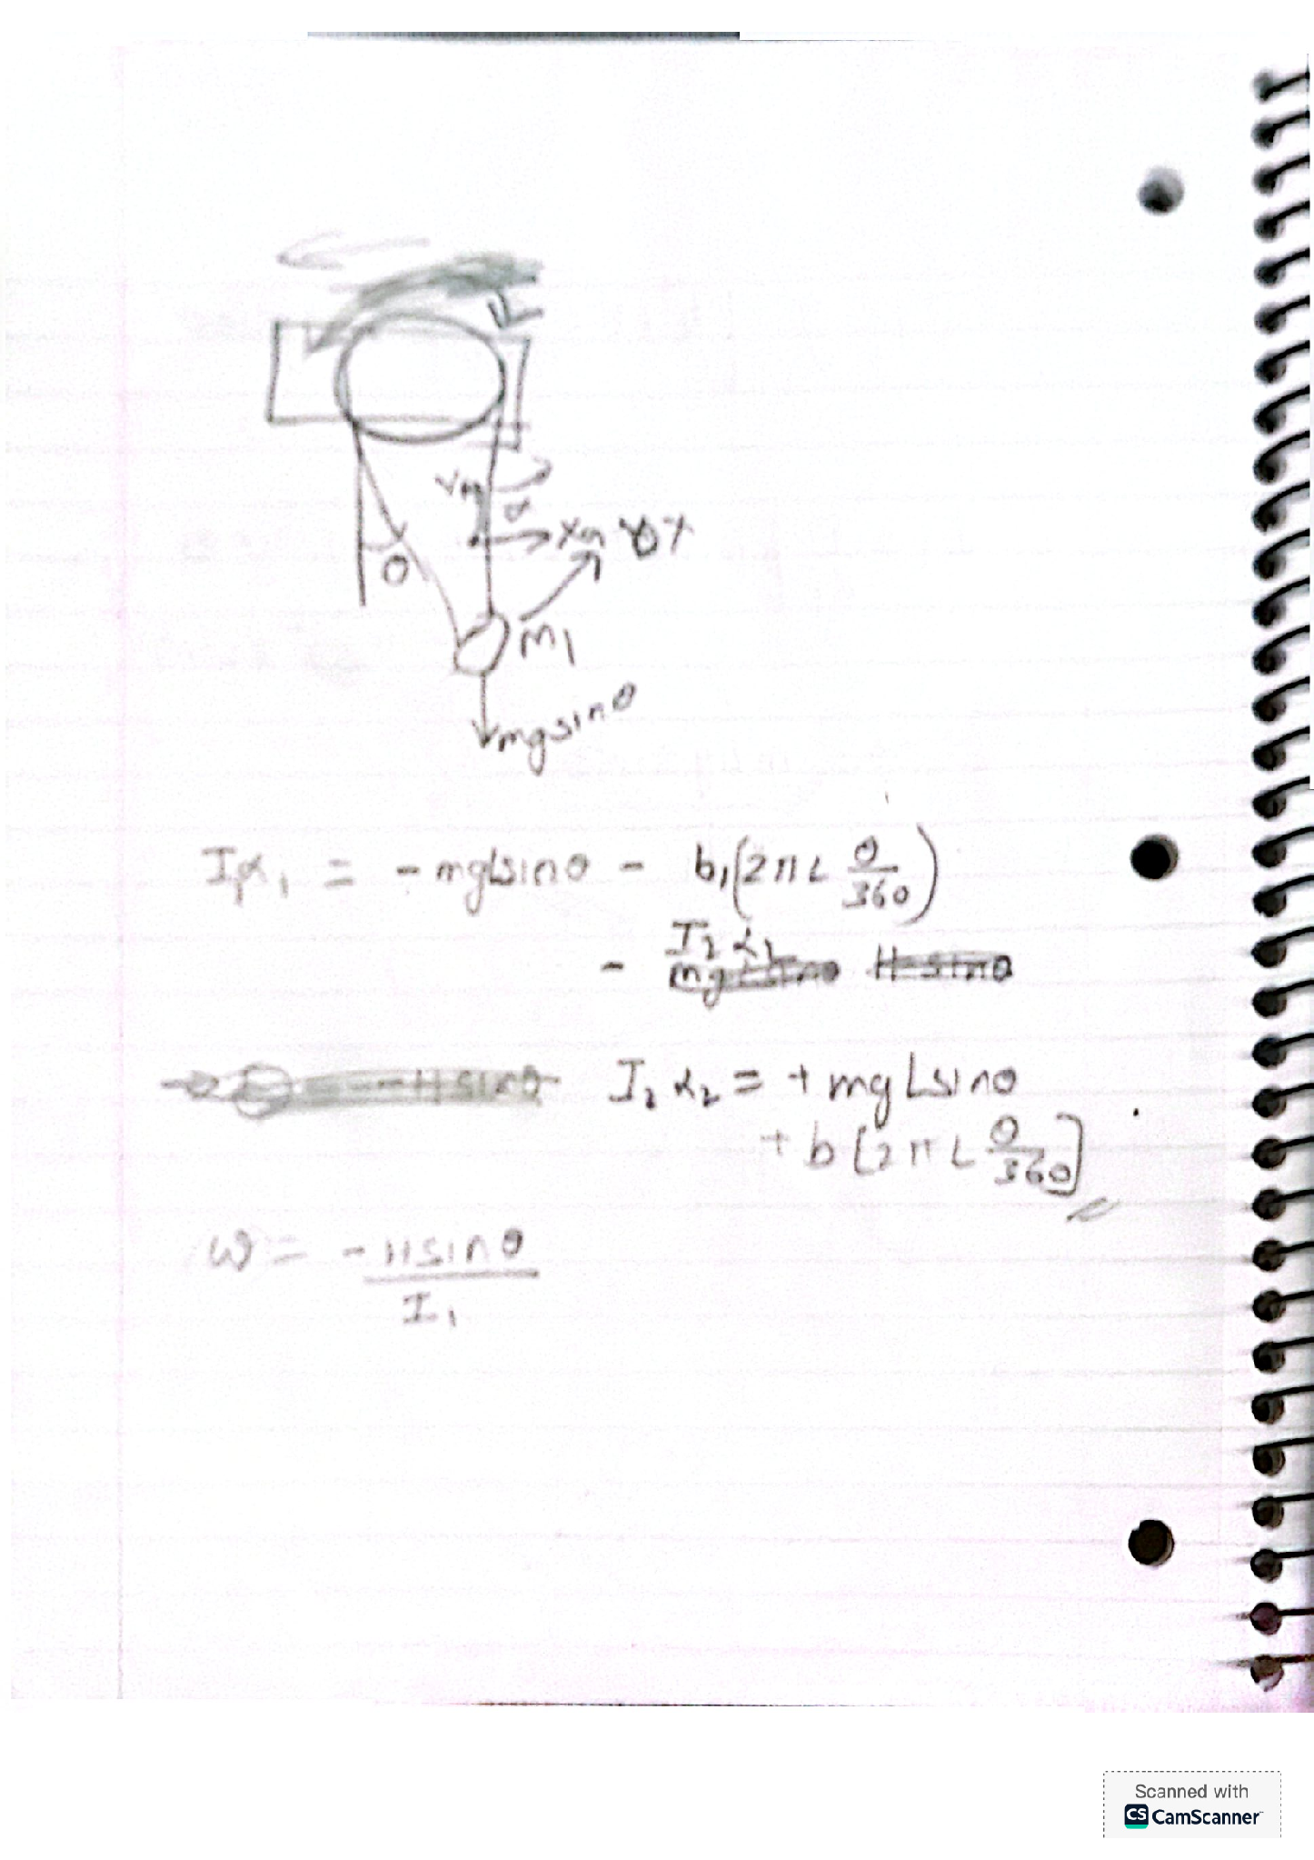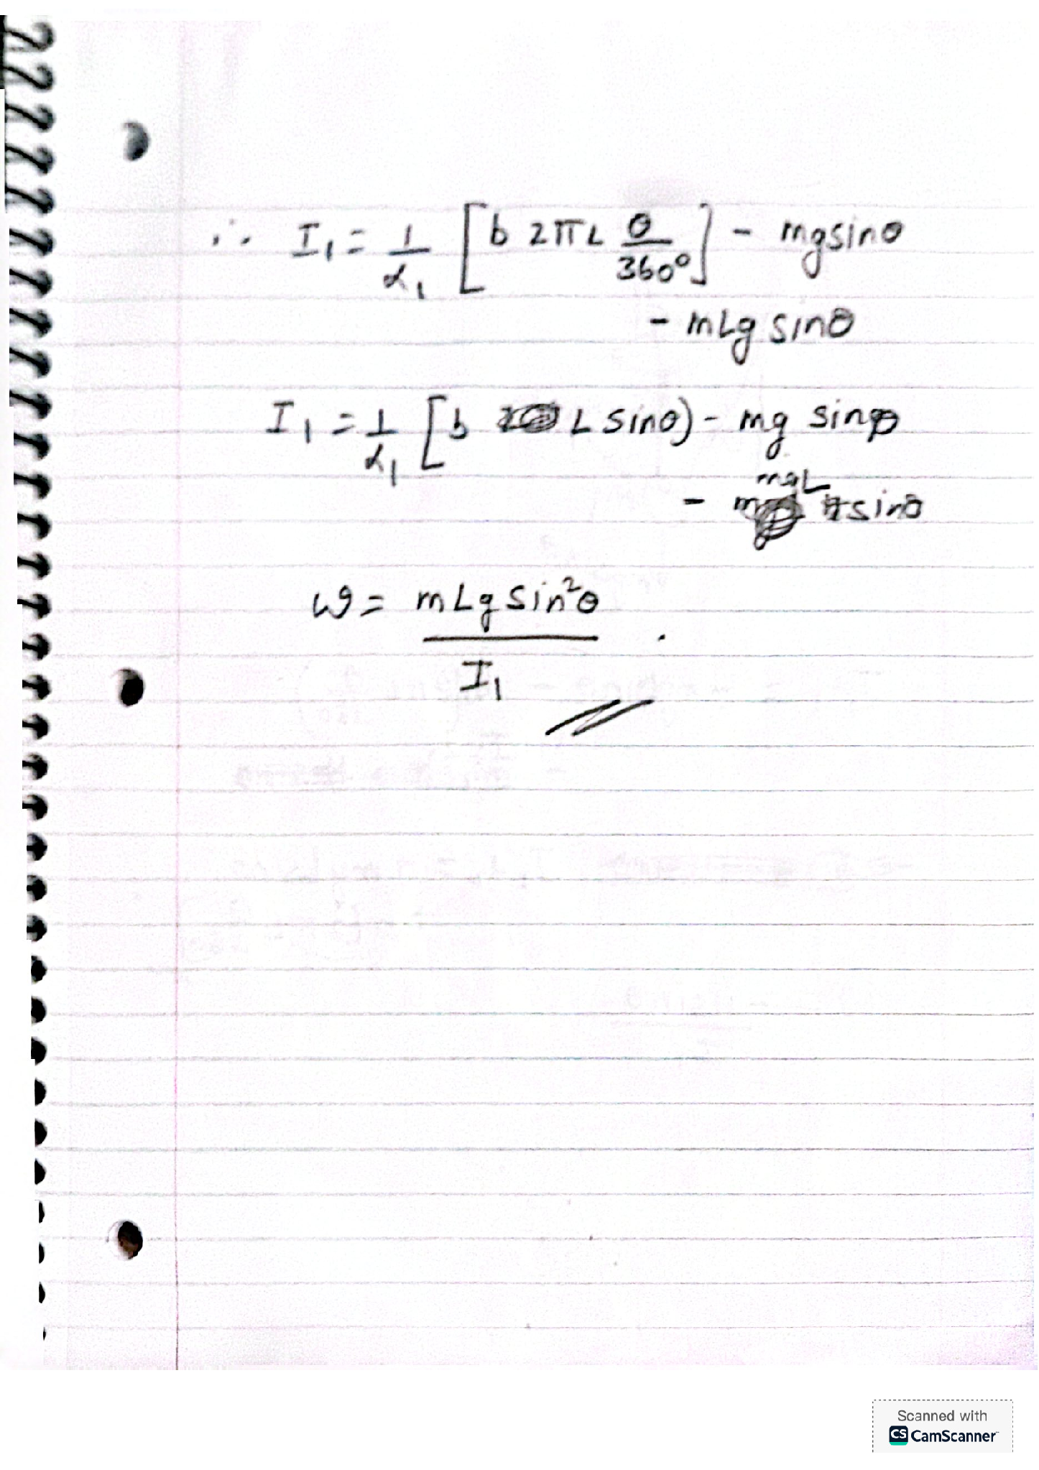
Figure 2 — Working derivation, page 1: force/torque balance and initial free-body setup, figure 3 —, page 2: reaction-pair torque balance between mass and shell, figure 4 — page 3: continued torque balance and angular velocity relation.
Using Newtonian mechanics I couldn’t mathematically derive the relationship required in this case so instead preferred to use Euler lagrangian to find the relation of to bypass complex calculations to obtain the required relationship. The EOM will be attached in a PDF file along with the debrief.

4. Current Status
- CAD model of outer shell and electromagnet ring layout complete (see attached video).
- Equations of motion drafted by hand; refined the Lagrangian formulation to correctly capture the fixed-radius eccentric-mass coupling complete.( see attached pdf file)
- Next step: implement the dynamics in Simulink to numerically verify the commutation-driven rolling behavior before sizing the electromagnets and building a prototype.
- Electromagnet force/duty-cycle sizing (accounting for centrifugal and gravity components on the mass) has not yet started.

5. What I'm Hoping to Discuss
I'm reaching out because I'd value feedback on the dynamics formulation and the overall feasibility of the magnetic commutation approach since a design idea with fluids as seen in the case of submarines would also be a good fit and I am confused if I am approaching this the right way, and I'm very interested in the possibility of contributing to ongoing research in your lab too. I'd be more than happy about the chance to discuss this project with you, and to learn whether there's alignment with current work you're leading.
Attachments: CAD render video (r2d2_v1.mp4)
EOM final (EOM final r1d2.pdf)

